**TABELA BLUEPRINT TEST PËRMBLEDHËS: BIOLOGJI 6 (SHTATOR–DHJETOR)**

|  |  |  |  |  |  |  |  |  |  |
| --- | --- | --- | --- | --- | --- | --- | --- | --- | --- |
| Tematika | **Rezultatet e të nxënit** | **Pesha** | **Niveli II**  **5-6** | | **Niveli III**  **7-8** | | **Niveli IV**  **9-10** | | **Gjithsej** |
| **Ushtrimi** | **Pikët** | **Ushtrimi** | **Pikët** | **Ushtrimi** | **Pikët** |
| Zinxhirët ushqimorë | Nxënësi/ja:   * Tregon marrëdhëniet ushqimore në   një habitat   * Emërton hallkat e një zinxhiri ushqimor * Përshkruan piramidën e numrit të individëve * Shpjegon terma në lidhje me zinxhirët ushqimorë | 52% | U 1/a  U 1/b  U 3/c | 3  3  1 | U 4 | 4 | U 1/c | 2 | 13 |
| Fotosinteza | Nxënësi/ja:   * Përshkruan procesin e fotosintezës * Shpjegon si ushqehen bimët * Analizon koncepte në lidhje me ndërveprimin e gjallesave me mjedisin dhe më njëra-tjetrën * Argumenton rëndësinë e bimëve në natyrë | 48% | U 3/b  U 3/e  U 3/f | 1  1  1 | U 2  U 3/a  U 3/d | 4  1  1 | U 5 | 3 | 12 |
| **Pikët sipas niveleve** | | | **10** | | **10** | | **5** | | **25** |
| **Përqindja sipas niveleve** | | | **40%** | | **40%** | | **20%** | | **100%** |

**TEST PËRMBLEDHËS GRUPI A**

**EMRI** ________________________________ **KLASA** ________

1. **Në rrjetin ushqimor:**

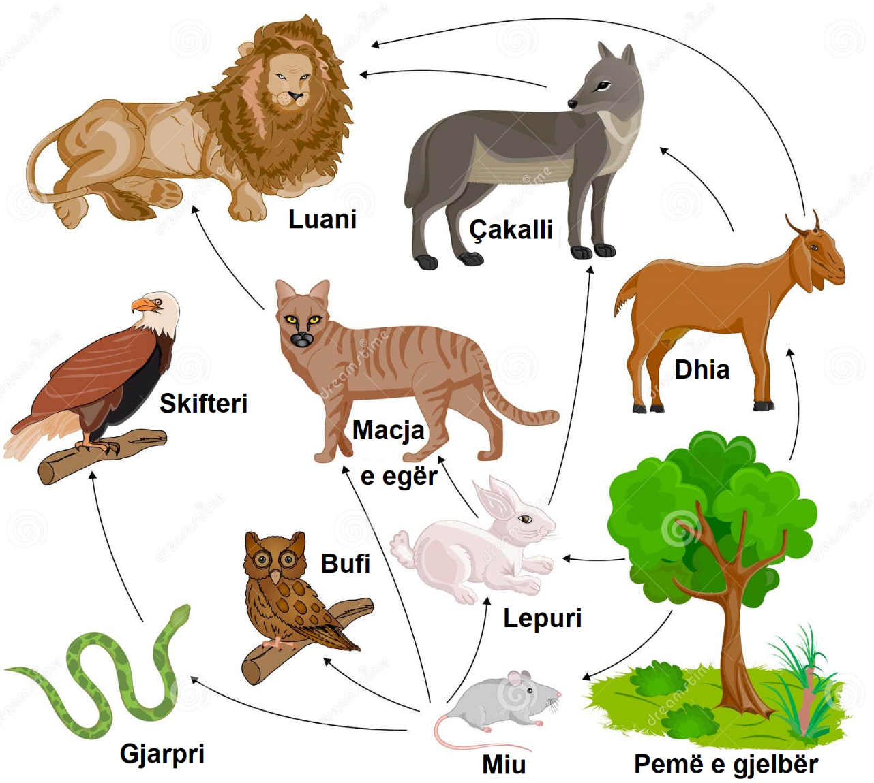

1. Shkruaj 3 zinxhirë ushqimorë nga rrjeti i mësipërm: **(3 pikë)**

______________________________________________________________________________________

______________________________________________________________________________________

______________________________________________________________________________________

______________________________________________________________________________________

1. Listo kafshët e rrjetit sipas rendit të mëposhtëm: **(3 pikë )**

Pre __________________________________________________________________________________

Grabitqarë ____________________________________________________________________________

Pre dhe grabitqarë _____________________________________________________________________

1. Pse në piramidën e numrit të individëve numri i barngrënësve është më i madh se i mishngrënësve? **(2 pikë )**

______________________________________________________________________________________

______________________________________________________________________________________

______________________________________________________________________________________

1. **Përshkruaj procesin e fotosintezës duke shfrytëzuar skemën e dhënë**,**: (4 pikë)**

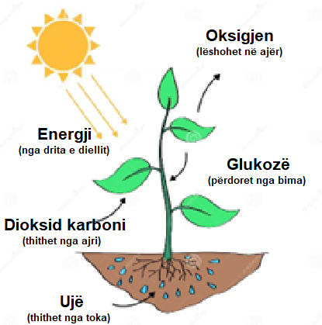____________________________________________________________________________________________

____________________________________________________________________________________________________________________________________________________________________________________________________________________________________________________________________________________________________________________________________________________________________________________________________________________________________________________________________________

1. **Vendos fjalët në fjalitë e mëposhtme: (6 pikë)**

*bimët, fitoplankton, zinxhiri ushqimor, dielli, piramidën e numrit të individëve, konsumatorët e parë*

1. ________________ marrin nga ajri dioksid karboni, nga toka ujin dhe kripërat minerale e në prani të dritës së diellit formojnë lëndët ushqyese.
2. ________________________________________fillon gjithmonë me bimët.
3. Algat si gjallesa të ulëta bimore formojnë ____________________________.
4. Kafshët mishngrënëse e marrin energjinë nëpërmjet të ushqyerit me ________________________.
5. Energjia që shfrytëzojnë të gjitha qeniet e gjalla vjen nga ____________________________.
6. Prodhuesit janë gjithmonë më tepër se konsumatorët e parë në ___________________________.

1. **Shpjego termat: (4 pikë)**

Plankton _______________________________________________________________________________________

_______________________________________________________________________________________

Rrjet ushqimor _______________________________________________________________________________________  
_______________________________________________________________________________________

Grabitqar

______________________________________________________________________________________________________________________________________________________________________________

Konsumator

_______________________________________________________________________________________

_______________________________________________________________________________________

1. **Bimët janë të rëndësishme për dy arsye: (3 pikë)**
2. ____________________________________________________________________________________
3. ____________________________________________________________________________________

|  |  |  |  |  |  |  |  |
| --- | --- | --- | --- | --- | --- | --- | --- |
| Nota | 4 | 5 | 6 | 7 | 8 | 9 | 10 |
| Pikët | 0-5 | 6-9 | 10-12 | 13-15 | 16-18 | 19-21 | 22-25 |

**TABELA BLUEPRINT TEST PËRMBLEDHËS: BIOLOGJI 6 (SHTATOR–DHJETOR)**

|  |  |  |  |  |  |  |  |  |  |
| --- | --- | --- | --- | --- | --- | --- | --- | --- | --- |
| Tematika | **Rezultatet e të nxënit** | **Pesha** | **Niveli II**  **5-6** | | **Niveli III**  **7-8** | | **Niveli IV**  **9-10** | | **Gjithsej** |
| **Ushtrimi** | **Pikët** | **Ushtrimi** | **Pikët** | **Ushtrimi** | **Pikët** |
| Zinxhirët ushqimorë | Nxënësi/ja:   * Tregon marrëdhëniet ushqimore në   një habitat   * Emërton hallkat e një zinxhiri ushqimor * Krahason zinxhirët ujorë me ato tokësorë * Shpjegon terma në lidhje me zinxhirët ushqimorë |  | U 1/a  U 1/b  U 3/c | 3  3  1 | U 4 | 4 | U 1/c | 2 | 13 |
| Fotosinteza | Nxënësi/ja:   * Ndërton piramidën e numrit të individëve dhe e argumenton atë * Shpjegon si ushqehen bimët * Analizon koncepte në lidhje me ndërveprimin e gjallesave me mjedisin dhe me njëra-tjetrën * Argumenton reaksionin e fotosintezës |  | U 3/b  U 3/e  U 3/f | 1  1  1 | U 2  U 3/a  U 3/d | 4  1  1 | U 5 | 3 | 12 |
| **Pikët sipas niveleve** | | | **10** | | **10** | | **5** | | **25** |
| **Përqindja sipas niveleve** | | | **40%** | | **40%** | | **20%** | | **100%** |

**TEST PËRMBLEDHËS GRUPI B**

**EMRI** ________________________________ **KLASA** ________

1. **Në rrjetin ushqimor:**

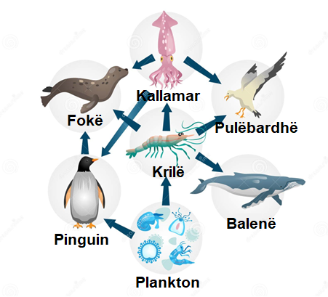

1. Shkruaj 3 zinxhirë ushqimorë nga rrjeti i mësipërm: **(3 pikë)**

_______________________________________________________________________________________

_______________________________________________________________________________________

_______________________________________________________________________________________

_______________________________________________________________________________________

1. Listoni kafshët e rrjetit sipas rendit të mëposhtëm: **(3 pikë)**

Pre _________________________________________________________________________________

Grabitqarë ____________________________________________________________________________

Pre dhe grabitqarë______________________________________________________________________

1. Pse zinxhirët ushqimorë të gjallesave ujore kanë më shumë hallka se ato të gjallesave tokësore?  **(3 pikë)**

_______________________________________________________________________________________

_______________________________________________________________________________________

_______________________________________________________________________________________

2. Në zonën ku pylli takohet me livadhin u gjendën: 1500 (rrënjë) bimë, 34 shpendë grabitqarë të vegjël, 325 flutura, 12 shpendë grabitqarë të mëdhenj**.**

Ndërtoni piramidën e numrit të individëve dhe tregoni prodhuesit dhe konsumatorët. **(4 pikë)**

**3. Vendos fjalët në fjalitë e mëposhtme: (6 pikë)**

*zooplankton, barngrënësit, lëndën ushqyese, konsumatorët, piramida e numrit të individëve, oksigjen*

1. ____________________ përfshin gjallesat e vogla shtazore që ushqehen me fitoplankton.
2. Janë konsumatorë të parë _____________________________ .
3. Algat shfrytëzojnë dritën e diellit, dioksidin e karbonit dhe kripërat e tretura në ujë për të përgatitur ________________________.
4. ______________________ mund të jenë grabitqarë ose pre.
5. Bimët e blerta nëpërmjet procesit të fotosintezës prodhojnë ___________________________.
6. ____________________________________ tregon ndryshimin e masës së gjallë të çdo hallke të vendosur mbi njëra-tjetrën.
7. **Shpjego termat: (3 pikë)**

Prodhues_________________________________________________________________________________________________________________________________________________________________________

Zinxhir ushqimor _________________________________________________________________________  
________________________________________________________________________________________ Fotosintezë_______________________________________________________________________________________________________________________________________________________________________

Pre______________________________________________________________________________________________________________________________________________________________________________

**5.** **Reaksioni i mëposhtëm shpreh procesin e fotosintezës. Plotësoni vendet bosh me fjalët e duhura:** **(3 pikë)**

__________________________ + ujë + energji diellore = _________________________ + oksigjen

|  |  |  |  |  |  |  |  |
| --- | --- | --- | --- | --- | --- | --- | --- |
| Nota | 4 | 5 | 6 | 7 | 8 | 9 | 10 |
| Pikët | 0-5 | 6-9 | 10-12 | 13-15 | 16-18 | 19-21 | 22-25 |